June Dinner Church
By Popular Demand:
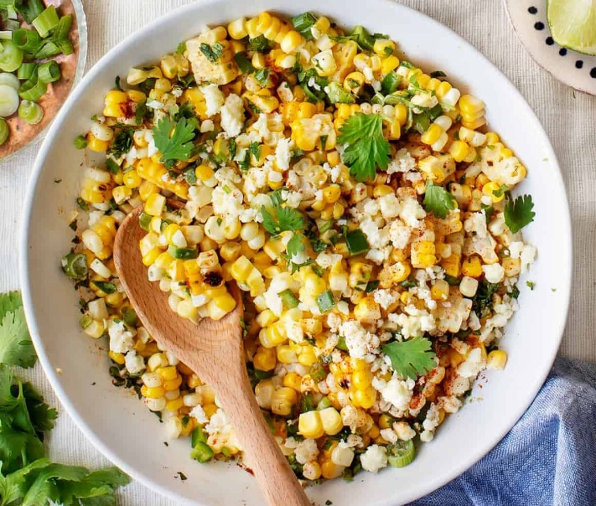
Chef Rob’s Corn Salad Recipe

2 tablespoons lime juice, plus extra for seasoning
3 tablespoons sour cream or plain Greek yogurt
1 tablespoon mayonnaise
1-2 serrano chilies, stemmed and cut into rings
2 tablespoons plus 1 teaspoon vegetable oil
6 ears corn kernels cut from cob (6 cups)
2 garlic cloves, minced
½ teaspoon chili powder
4 ounces cotija cheese, crumbled (1 cup)
¾ cup coarsely chopped fresh cilantro
3 scallions, thinly sliced
Table salt

1. Combine lime juice, sour cream, mayonnaise, serranos and ¼ teaspoon salt in a large bowl. Set aside.
2. Heat 1 tablespoon oil in a 12-inch nonstick skillet over high heat until shimmering. Add half of corn and spread into even layer. Sprinkle with ¼ teaspoon salt. Cover and cook, without stiffing, until corn touching the skillet is charred (about 3 minutes). Remove skillet from heat and let stand, covered, for 15 seconds, until any popping subsides. Transfer corn to bowl with sour cream mixture. Repeat with remaining oil, corn, and salt.
3. Return now-empty skillet to medium heat and add remaining 1 teaspoon oil, garlic, and chili powder. Cook, stirring constantly until fragrant, about 30 seconds. Transfer garlic mixture to bowl with corn mixture and toss to combine. Let cool for at least 15 minutes.
4. Add cotija, cilantro, and scallions. Toss to combine. Season salad with salt and additional lime juice, to taste. Serve.

